

**Group Meeting #1**

The meeting of TeamSix has decided at FPT University at 13th March 2021.

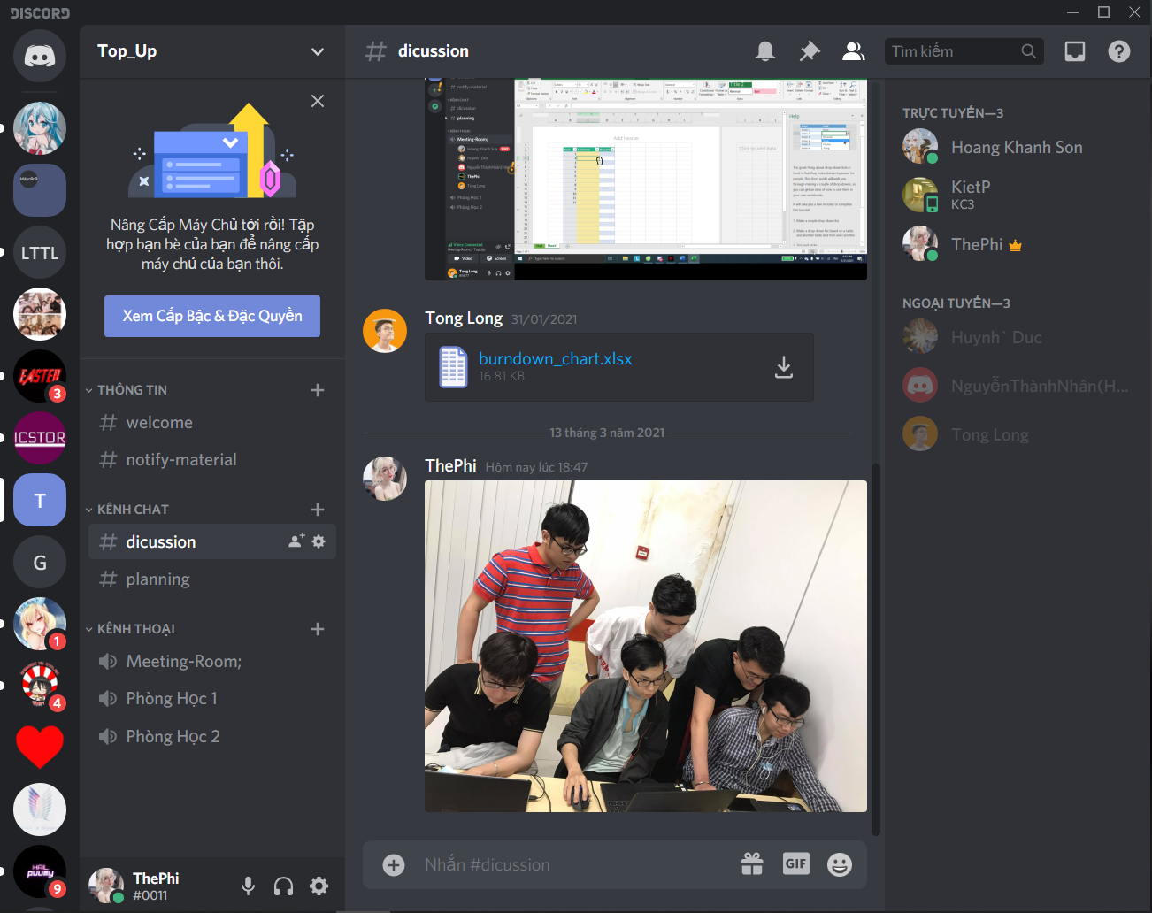

**Attend present**

Pham The Phi

Hoang Khanh Son

Nguyen Hoang Nhan

Trinh Huynh Duc

Tong Dam Thang Long

Pham Tuan Kiet

**Member Not Attendance**

None.

**Report about**

Discuss BackLog and SprintLog, ERD.

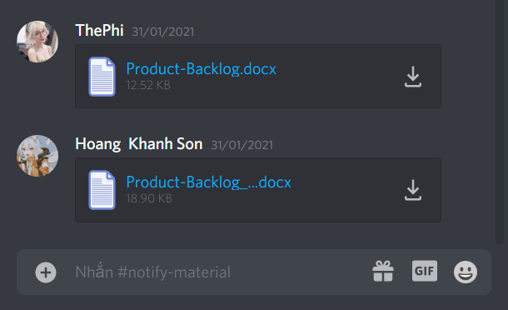

**Time Meeting**

An initial team discussion about the project was held on 13th March, 2021 at 20h00.

**Approve comments during the meeting**

Everyone agrees with the plan.

**Unfinished Work**

Follow up project.

**Next Work**

Work will hold at the next meeting at 14th March 2021.

**Work progress**

Normal. Nothing unexpected happening.